COS10026 Assignment 2

Name: Nur E Siam

ID: 103842784

Introduction

In the assignment 2, we extended our html files from our first assignment to php files with database connection. This report will outline the structure of the website, what we as a group (including Aiden large, Hridita Dewan, Tahseen Zubayer) have done, and also reflect on what we have done throughout the semester.

The Website

Our website is about laptop and computer purchase, which we have named it to ‘Pixel-8’. We have six pages on the website – index, about, product, payment, enhancements, and management. All pages are linked to each other by header, footer and navigation bar which we did by making .inc files.

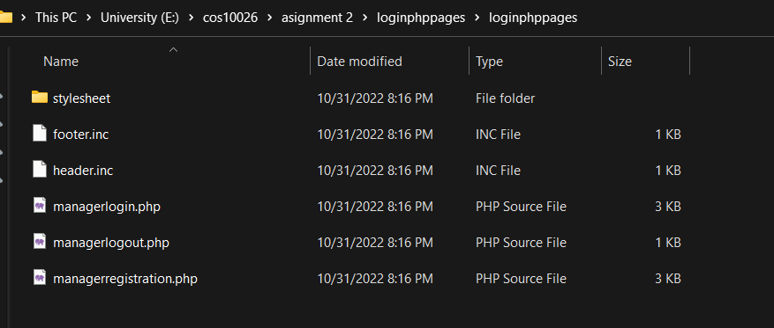
Includes folder that has our header, footer and menu.


Outline of our home page.

Most of our pages are similar to what we have done in the first assignment. What we have modified is the payment.php page which was initially enquire.html, as suggested by the instructions. We have set our payment page to allow customers select the type of laptop and computers they want to buy as well as how many.
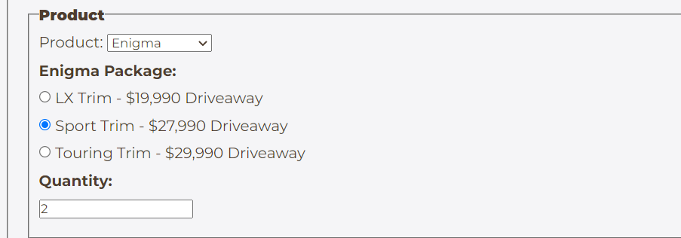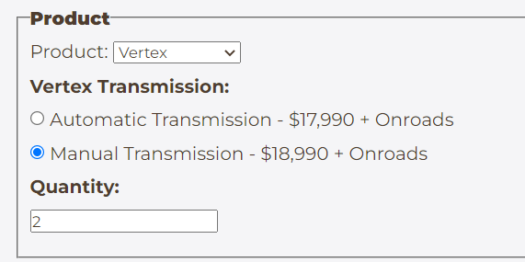
Product fieldset on payment.php page

We have also added payment details which lets the users type in their credit card details which could be any of three type of cards – Visa, Mastercard or American Express.
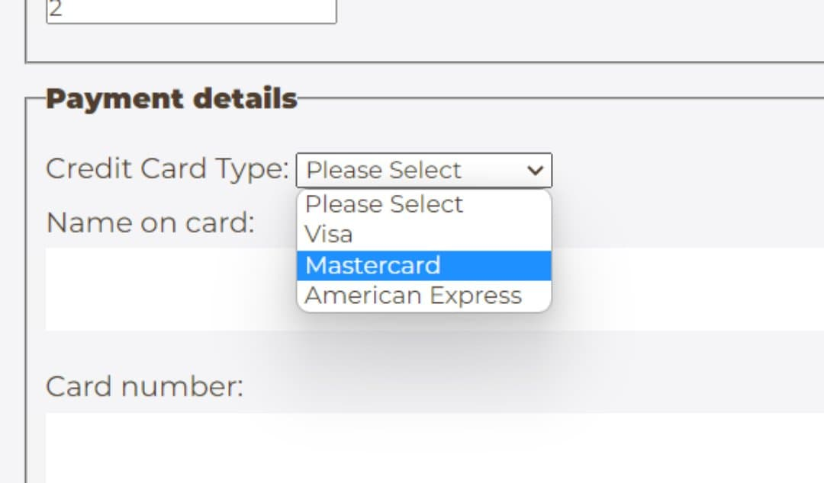

Using process_order.php, we have set error messages for wrong inputs for card numbers. For example, if you type in your Mastercard number starting with 4 or the card number is less than or more than 16, it will show error and take you to fix_order.php, which is basically the form page of the payment page to allow customers re-type the inputs before checking out.
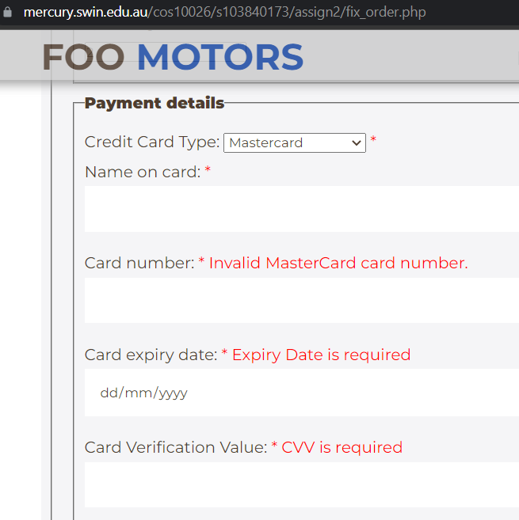
Error message when invalid card number is typed in and other sections left empty.

All of the details when checked out will be added to our database. Customers will get a receipt of what they have typed in.

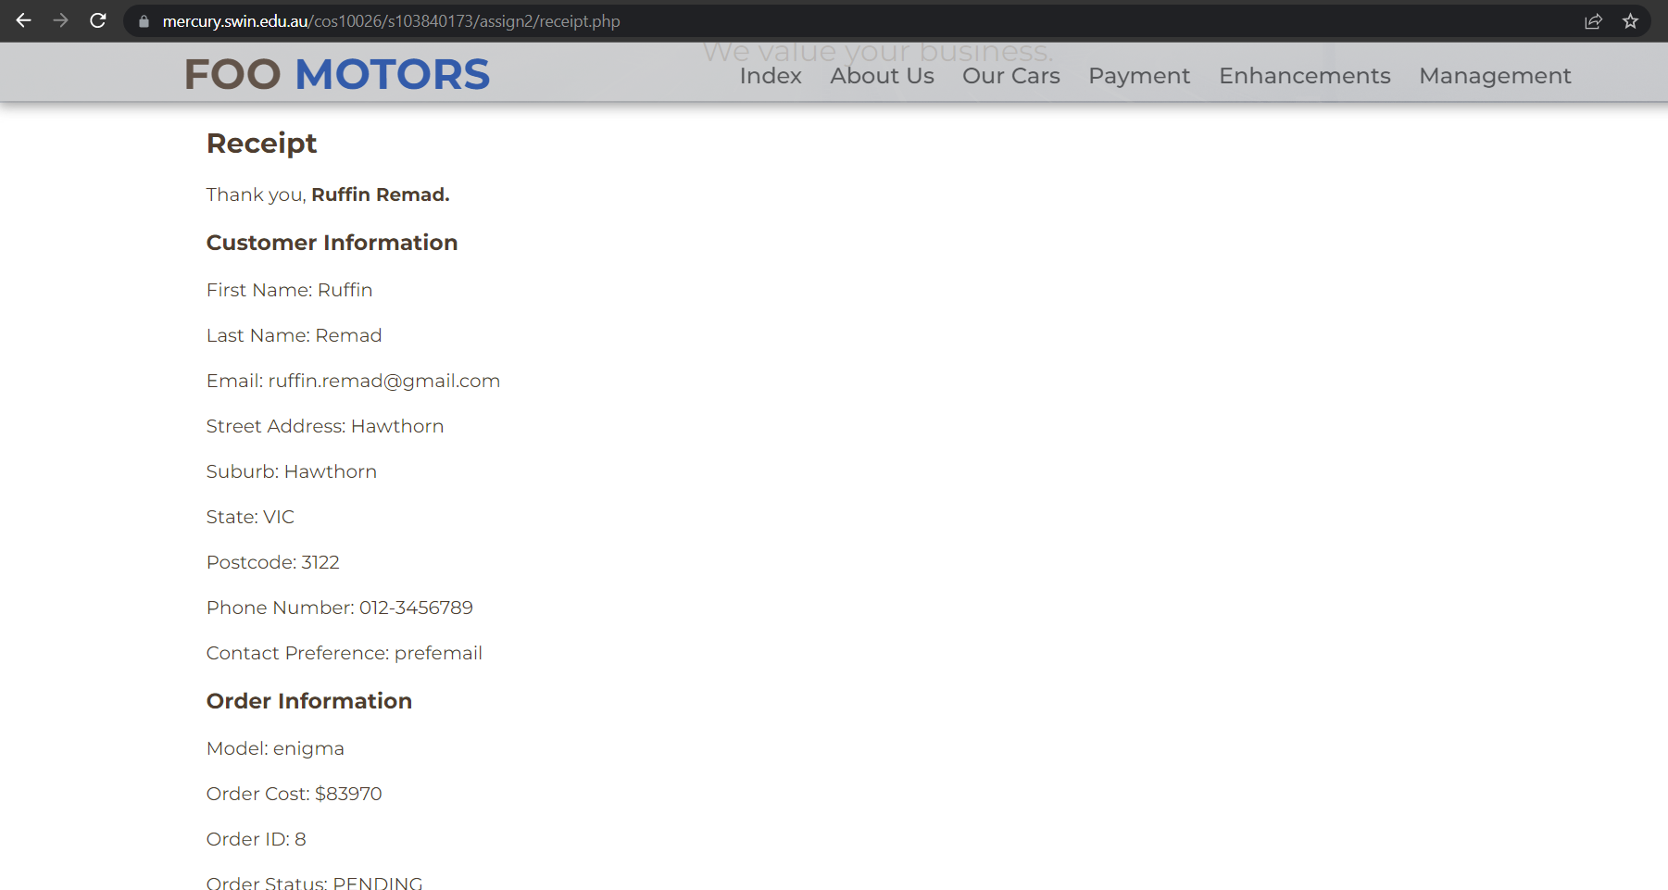
Receipt page

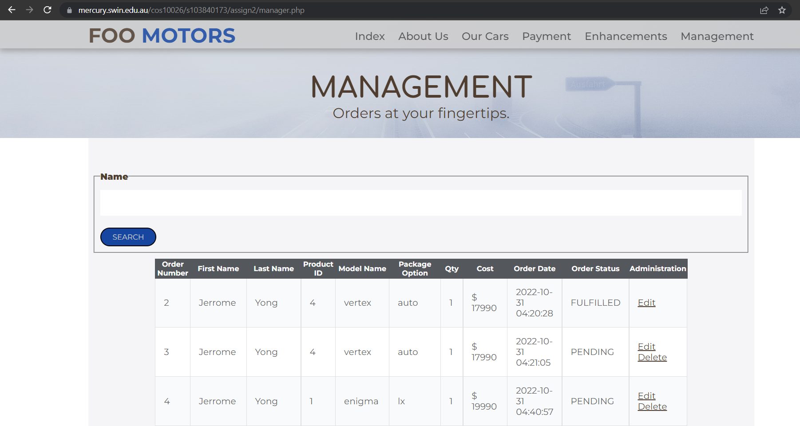
manager.php displaying all the orders made

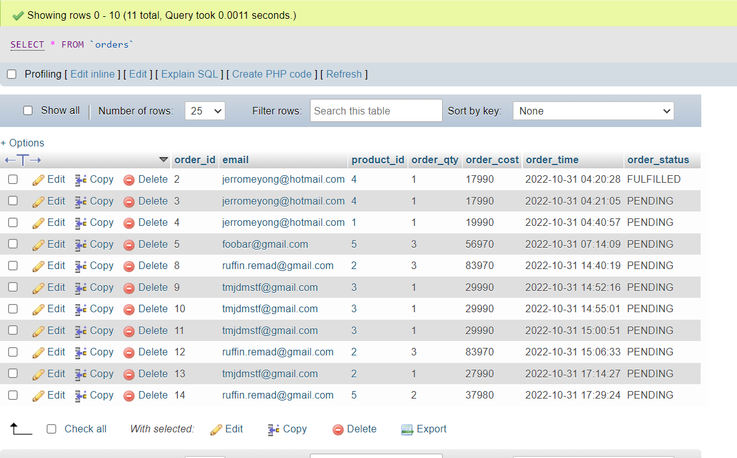
Orders table on the database

All the data entries go to one database which is done by settings.php and manager.php

My contribution

I have changed the enquire page to payment page which I modified to add credit card details and show error messages for any wrong inputs made. I also made the receipt page which prints out all the user inputs on purchases made. I also set up the MySQL table from the database, on which the whole team worked.

Reflection and discussion

On a personal note, I have enjoyed working with my team members which helped me improve my communications skills and gave me courage to integrate among group work. I have learned how to deal with deadlines as a group, which is different from individual ones as we had to make sure everyone gets their work done on time and later compile it.
One thing that needs to be considered during a project is, how commercially viable it is, how general people will take it. As we made a car purchase website, I will consider how profitable the business will be if I am working in a professional arena. Other issues such as social issues and sustainability stem from commerciality in the current world.
In a real world scenario, Foo Motors would have been a car brand that would have run its business like Ford or Volkswagen. The website will play a vital role in presenting the products, facilities and other features to the general public, who will decide whether to make purchases or not.

Conclusion

To sum it up, this assignment 2 was a step up from the first one where we applied new language and faced more complicated situations such as managing the forms and database. This also enhanced our capabilities to contribute in a group work as well as making us ready for real-world situations.

